**Title of the work**

Patent and IPR filling

**Name of the Project**

OceanGuard: Autonomous Marine Waste Cleanup and Recycling System

**A Patent Report**

Submitted in partial fulfillment of the requirements for the award of degree of

**Name of Degree**

Bachelor of Technology (CSE)

**Submitted to**

**LOVELY PROFESSIONAL UNIVERSITY**

 **PHAGWARA, PUNJAB**

**SUBMITTED BY**

**Name of student:** Chitranshu Kushwaha

**Registration Number:** 12114373

**Signature of the student:**



**Title:**

**OceanGuard: Autonomous Marine Waste Cleanup and Recycling System.**

**Inventors / Students:**

|  |  |
| --- | --- |
| **1**. Full Name | Pratham Thakur |
| Mobile no: | 7584073839 |
| Email: | prathamthakur1302@gmail.com |
| Registration number: | 12114778 |
| Permanent Address: | Darjeeling, West Bengal, 734201 |
| **2**. Full Name | Yash Pandey |
| Mobile no: | 7835918195 |
| Email: | yashpandey072@gmail.com |
| Registration number: | 12114688 |
| Permanent Address: | Samta Enclave, Qutub Vihar, New Delhi 110071 |
| **3**. Full Name | Prince Raj |
| Mobile no: | 9135048296 |
| Email: | princeraj7173@gmail.com |
| Registration number: | 12114539 |
| Permanent Address: | Subash Nagar lane no 04, Station Road, Rohtas, Bihar 821307 |
| **4**. Full Name | Chitranshu Kushwaha |
| Mobile no: | 7668187463 |
| Email: | Ronakkushwaha123gmail.com |
| Registration number: | 12114373 |
| Permanent Address: | 233, Banarsidas, Auraiya, Uttar Pradesh |

**DESCRIPTION OF THE INVENTION**

1. PROBLEM ADDRESSED BY THE INVENTION:

The invention at hand addresses a critical environmental crisis: ocean pollution, predominantly caused by plastic waste. Current methodologies for mitigating marine debris fall short in terms of efficiency and ecological impact. The proliferation of plastic waste in the world's oceans poses an imminent threat to marine ecosystems. The primary objective of this invention is to introduce a groundbreaking Automated Marine Waste Collection and Processing System.

1. STATE OF THE ART / RESEARCH GAP:

Contemporary approaches to marine debris remediation predominantly rely on manual labor, and conventional vessels have intrinsic limitations. While nascent technologies like drones and robotic systems have made appearances in this domain, they exhibit a gap in advanced capabilities and holistic integration. This innovation bridges this chasm by leveraging cutting-edge robotics, Artificial Intelligence (AI), and sustainable waste processing technologies for a comprehensive solution.

1. DETAILED DESCRIPTION:

The Automated Marine Waste Collection and Processing System is an intricate ecosystem of advanced components and technologies, culminating in an unparalleled solution to ocean pollution:

Drone Fleet: A sophisticated fleet of autonomous drones, endowed with state-of-the-art computer vision, machine learning algorithms, and environmental sensors, takes to the skies and waters. The drones operate in a synchronized manner, scanning vast ocean expanses in search of marine debris.

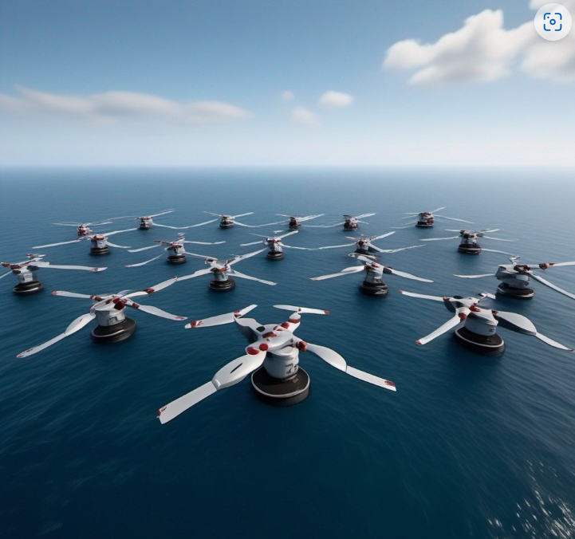 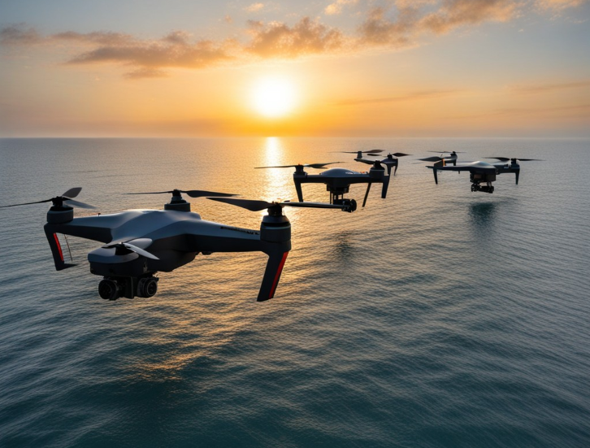

Robotic Retrieval: Each drone boasts robotic appendages that execute precise, non-invasive retrieval maneuvers. These robotic arms are not merely mechanical extensions; they are AI-powered, utilizing intricate object recognition algorithms to identify and capture pollutants such as plastic bottles and bags.

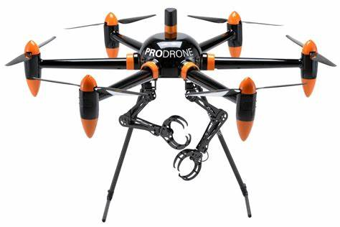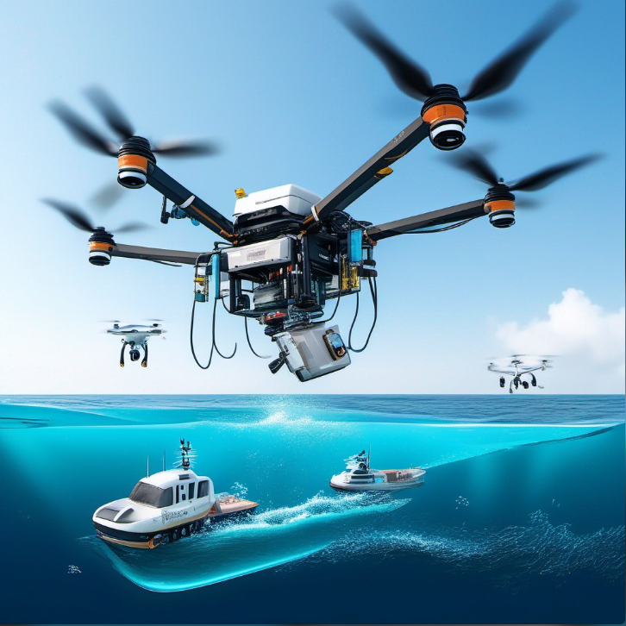

Sustainable Processing: Onboard waste processing units represent the pinnacle of eco-responsibility. Using groundbreaking technology, these units are capable of shredding, melting, and transforming collected plastic waste into reusable materials or sustainable energy sources. The choice of environmentally friendly materials and processes ensures minimal ecological footprint.

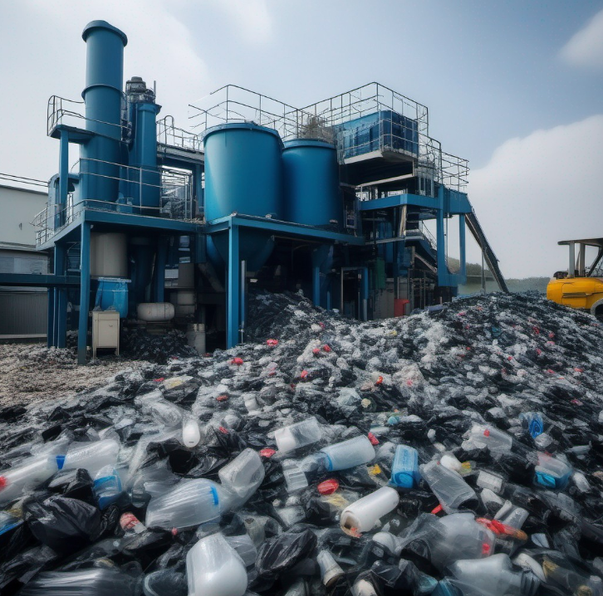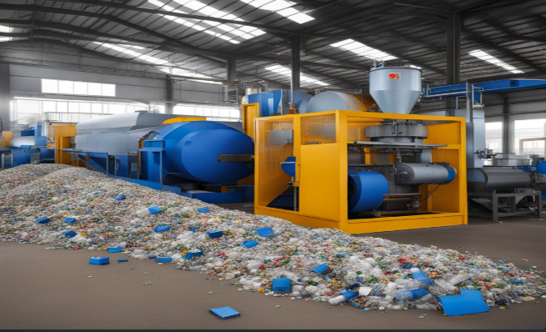

Navigation and Coordination: The fleet operates as an interconnected network, guided by cutting-edge AI for path planning and collision avoidance. The drones collaborate in real-time, efficiently covering extensive areas while avoiding collisions with each other, other vessels, and marine life, thanks to advanced algorithms and precise satellite positioning.

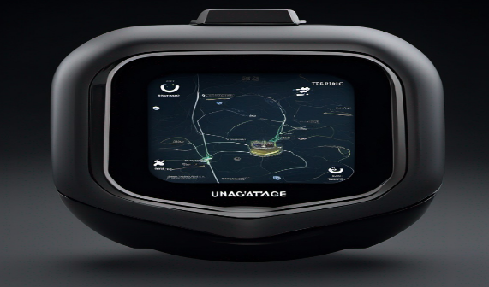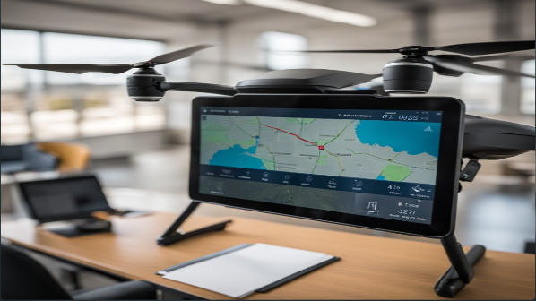

Remote Monitoring: At the heart of the system is a centralized command center, equipped with real-time data streams from the drone fleet. Operators exercise control, make on-the-fly adjustments, and optimize operations. The interface is intuitive, providing critical situational awareness.

1. RESULTS AND ADVANTAGES:

This invention promises a multitude of advantages. Not only does it significantly reduce ocean pollution and safeguard marine ecosystems, but it also actively contributes to the recycling of plastic waste, potentially curtailing the demand for new plastic production. Beyond environmental benefits, the system has versatile applications in coastal cleanup efforts, disaster response scenarios, and proactive environmental conservation initiatives. It also positions organizations and governments as responsible stewards of the environment, yielding positive public relations and a profound corporate social responsibility impact.

1. ALTERNATIVES / EXPANSION:

To further amplify the innovation, ongoing collaboration with marine biologists, environmental experts, and robotics engineers will perpetuate refinements. Future expansions may involve more intricate AI for precise waste detection and sorting, as well as adaptability to diverse marine ecosystems, customizing the system to address localized challenges effectively.

1. WORKING PROTOTYPE / FORMULATION / DESIGN / COMPOSITION:

The working prototype is in advanced stages of development and will be primed for testing within the next 12-18 months. The integration of AI and advanced robotics demands meticulous testing and calibration to ensure seamless functionality.

*How It Works:*

The drone fleet is launched from a designated base or vessel and dispersed over the

target ocean area.

1. Drones autonomously scan the surface of the water and the skies above, utilizing their advanced sensors and computer vision to detect marine debris.
2. When a drone identifies a piece of plastic waste, its AI-powered robotic arm deploys to capture the item with precision.
3. The collected waste is transported back to the base or vessel where the waste processing units are located.
4. The waste is then subjected to the sustainable processing units, where it is shredded, melted, and transformed into reusable materials or converted into sustainable energy sources.
5. The entire process is closely monitored and managed from the centralized command centre, allowing operators to adjust drone operations and processing as needed.

***Technology required to implement Drone fleet:***

1. **Camera and Computer Vision:**

* High-resolution cameras: These are essential for capturing visual data and images of the ocean surface.
* Computer vision algorithms: These enable object recognition and detection of marine debris, helping the drones identify and locate plastic waste.

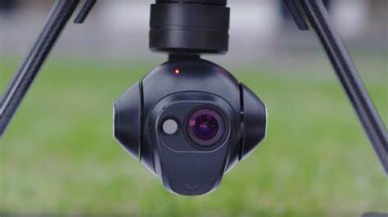

1. **LiDAR (Light Detection and Ranging):**

* LiDAR sensors provide 3D mapping capabilities, allowing drones to create detailed maps of the ocean surface and detect objects both on the water's surface and underwater.

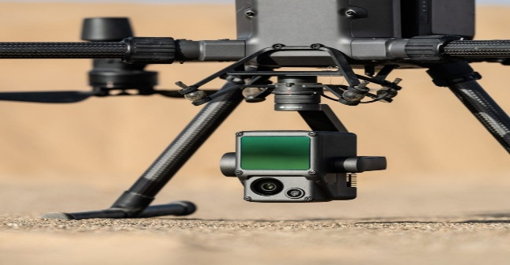

1. **GPS and GNSS (Global Navigation Satellite System):**

* GPS and GNSS technology provides accurate positioning data, helping drones navigate, maintain their positions, and plan efficient flight paths.

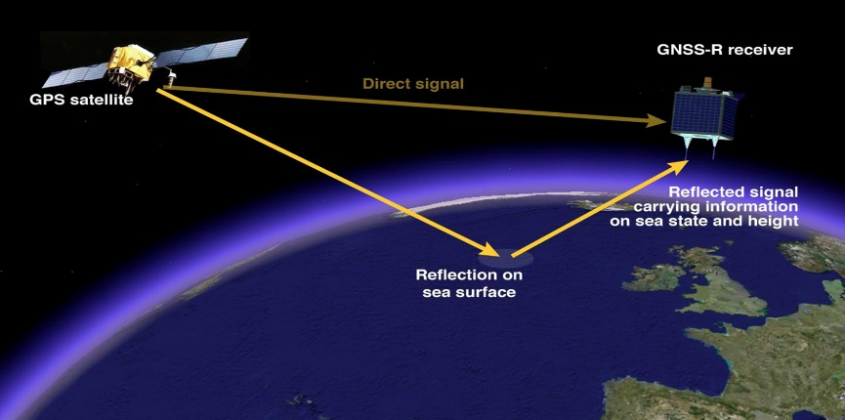

1. **Sonar Sensors:**

* Sonar sensors can be used to detect underwater debris, such as submerged plastics, by emitting sound waves and measuring their return time.

1. **Radar:**

* Radar technology can be valuable for detecting larger marine debris or obstacles, such as large pieces of plastic or other vessels in the vicinity.

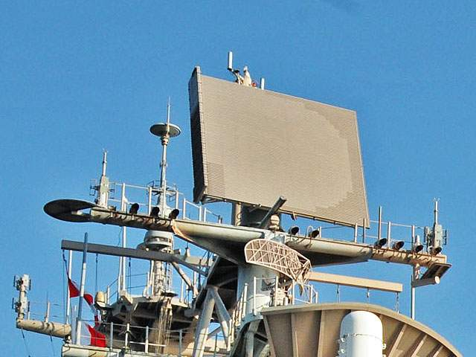

1. **AIS (Automatic Identification System):**

* AIS is commonly used to identify and track maritime vessels. It can be integrated into the drone fleet to avoid collisions with ships and boats.

1. **Communication Systems:**

* Reliable communication systems are crucial for transmitting data between drones and the central command center, enabling real-time monitoring and control.

1. **Machine Learning and AI Algorithms:**

* AI algorithms can process data from various sensors and make decisions in real-time, such as identifying and categorizing types of debris.
* **YOLO (You Only Look Once):**

Description: YOLO is a real-time object detection algorithm that stands out for its speed and accuracy. It processes images or video frames and identifies objects within them. Unlike some other object detection methods, YOLO performs detection in a single pass through the neural network, making it exceptionally efficient for real-time applications.

Application: In the context of your system, YOLO can be used to identify and locate marine debris items on the ocean's surface or within the water. It can quickly detect and pinpoint objects like plastic bottles, bags, or larger debris items.

* **Mask R-CNN (Mask Region-based Convolutional Neural Network):**

Description: Mask R-CNN is an extension of the Faster R-CNN object detection framework. It not only identifies objects in images but also provides pixel-level segmentation, delineating the exact boundaries of objects. This segmentation capability is valuable when precise object boundaries need to be known, such as when collecting marine debris without harming marine life.

Application: Mask R-CNN can be used to create detailed masks around marine debris items, making it easier for the robotic arms of the drones to grasp them without causing damage to the surrounding environment or other organisms.

* **Reinforcement Learning (RL):**

Description: Reinforcement learning is a type of machine learning where agents learn to make decisions by interacting with an environment. Agents receive rewards or penalties based on their actions and learn to maximize their cumulative reward over time. It's particularly useful for training drones to make intelligent decisions.

Application: In the context of your system, reinforcement learning can be used to teach drones how to make decisions about waste retrieval. Drones can learn to prioritize which debris to collect first based on factors like safety, efficiency, and the environmental impact of the waste.

* **Bayesian Networks:**

Description: Bayesian networks are probabilistic graphical models that represent the probabilistic relationships among a set of variables. They are used for reasoning under uncertainty and can help in decision-making by assessing probabilities.

* Application: In the context of your system, Bayesian networks can be used to assess the likelihood of encountering marine debris in specific areas. They can take into account various factors, such as historical data on debris concentration, current environmental conditions (e.g., ocean currents, wind patterns), and sensor data from the drones. This helps in making informed decisions about where to deploy the drone fleet for optimal debris collection.

1. **Battery and Power Management:**

* Advanced battery technology and power management systems are essential for prolonged drone flight times, allowing for extended data collection and waste retrieval operations.

***Technology required to implement Robotic Retrieval:***

1. **Integration of Advanced Robotic Arms:**

The cornerstone of our system's functionality lies in the integration of highly advanced robotic arms. These robotic arms are engineered to possess multiple degrees of freedom, which allows them to perform intricate movements and tasks. They are meticulously designed to be lightweight, making them agile and responsive to the dynamic marine environment. Moreover, they are robust and durable, ensuring that they can withstand the challenging conditions of the open ocean. By equipping the system with these advanced robotic arms, we ensure that it can precisely extend towards marine debris and execute retrieval with utmost precision.

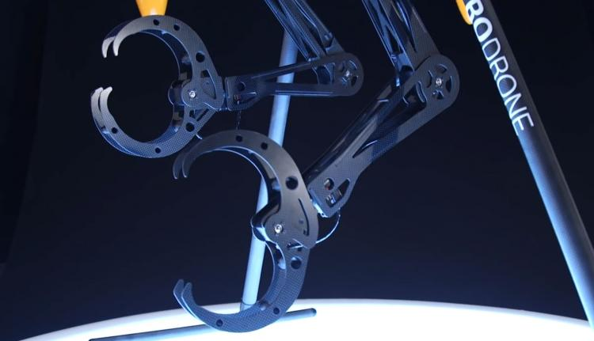

1. **Smart End-Effectors for Delicate Grasping:**

To successfully retrieve marine debris, we've chosen specialized end-effectors, or grippers, which are specifically designed to execute gentle yet firm grasps. These end-effectors are meticulously engineered to accommodate a wide range of waste items, from rigid plastic bottles to more delicate materials. The design of these grippers ensures that they apply balanced force when grasping debris, thereby preventing any damage to the items collected. This approach not only protects the integrity of the marine debris but also significantly reduces the risk of harm to the surrounding marine ecosystem.

1. **Real-Time Sensor Feedback and Control:**

The robotic retrieval process is enhanced by a real-time feedback and control system. Force and tactile sensors are seamlessly integrated into the robotic arms to provide immediate sensory information during the grasping operation. This feature allows the robotic arms to sense and respond to the force exerted during the retrieval process. In practical terms, it means that the arms have a delicate touch when interacting with marine debris. If any unexpected resistance is encountered, the system can promptly adjust its actions, guaranteeing that it treats both the collected items and the surrounding marine environment with the utmost care and sensitivity.

1. **Machine Learning for Adaptive Grasping:**

One of the key strengths of our system lies in its adaptability, which is achieved through the incorporation of machine learning algorithms. These algorithms grant the robotic arms the ability to recognize and adapt to the various shapes, sizes, and characteristics of debris items encountered during retrieval missions. As the system operates and collects more data, it continuously learns and refines its grasping techniques. This adaptive approach ensures that the system can efficiently and effectively handle the wide array of marine debris that it may encounter in the ocean. The system's ability to adapt and make informed decisions in real-time significantly enhances the overall efficiency of waste retrieval, regardless of the variability and complexity of the debris items encountered.

***Methods required to implement Sustainable Processing:***

1. **Mechanical Recycling:**

* Shredding: Mechanical recycling begins with shredding, where collected plastic waste is broken down into smaller, more manageable pieces. This initial step facilitates the subsequent processing of plastics and is crucial for efficient recycling.
* Extrusion: Following shredding, extrusion is employed to melt and shape the shredded plastic. The heated plastic is passed through an extruder to create various forms, such as pellets, sheets, or other raw materials. This process is highly versatile and suitable for producing a wide range of products.

1. **Chemical Recycling:**

* Pyrolysis: Pyrolysis is a chemical recycling method that involves the thermal decomposition of plastics in the absence of oxygen. This process transforms plastics into valuable products like fuel oils and gases, making it especially useful for plastics that are challenging to mechanically recycle.
* Depolymerization: Depolymerization is another chemical recycling technique. It involves breaking down plastics into their original monomers, essentially returning them to their initial building blocks. These monomers can then be used to create new plastics or other products.

1. **Energy Recovery:**

* Waste-to-Energy (WtE) Conversion: A sustainable processing unit can be equipped with waste-to-energy technology to convert plastic waste into useful energy sources. This approach not only reduces the volume of plastic waste but also generates clean energy in the form of electricity or heat, contributing to sustainable power generation.

1. **Sustainability Assessment:**

* A life cycle assessment (LCA) is conducted to evaluate the overall environmental impact of the sustainable processing unit. This comprehensive assessment takes into account energy consumption, emissions, resource usage, and other factors to ensure that the processing unit aligns with sustainability goals.

1. **Quality Control and Sorting:**

* The processing unit is equipped with advanced sorting technologies that automatically separate different types of plastics based on their recyclability, quality, and potential uses. This step ensures that only suitable materials enter the recycling and transformation processes.

1. **Regulatory Compliance:**

* The processing unit diligently adheres to environmental regulations and standards related to waste processing and recycling. Compliance ensures that the unit operates within legal and ethical boundaries, maintaining environmental and social integrity.

1. DATA:

Detailed clinical and comparative data, to be gathered during extensive testing, will substantiate the profound impact of the Automated Marine Waste Collection and Processing System on ocean pollution reduction, resource recovery, and the overall betterment of marine ecosystems. These datasets will exemplify the innovation's superiority over existing methodologies.

**USE AND DISCLOSURE (IMPORTANT):**

|  |  |  |
| --- | --- | --- |
| A. Have you described or shown your invention/ design to anyone or in any conference? | YES ( ) | NO (Checkmark) |
| B. Have you made any attempts to commercialize your invention (for example, have you approached any companies about purchasing or manufacturing your invention)? | YES ( ) | NO (Checkmark) |
| C. Has your invention been described in any printed publication, or any other form of media, such as the Internet? | YES ( ) | NO (Checkmark) |
| D. Do you have any collaboration with any other institute or organization on the same? Provide name and other details. | YES ( ) | NO (Checkmark) |
| E. Name of Regulatory body or any other approvals if required. | YES ( ) | NO (Checkmark) |

**List of companies which can be contacted for commercialization along with the website link:**

Ocean Cleanup (Website: <https://theoceancleanup.com/>)

WasteShark (Website: <https://www.wasteshark.com/>)

Seabin Project (Website: <https://seabinproject.com/>)

Terracycle (Website: <https://www.terracycle.com/>)

4Ocean (Website: <https://4ocean.com/>)

**Market potential of the invention:**

The market potential for the Automated Marine Waste Collection and Processing System is substantial. With the increasing global concern about ocean pollution and the urgent need to address plastic waste in marine environments, there is a growing demand for innovative solutions. The market includes environmental organizations, governments, coastal communities, and industries involved in sustainability efforts. Additionally, the system can be adapted for disaster response and proactive environmental conservation initiatives, expanding its market potential.

**Any basic patent which has been used and we need to pay royalty to them:**

After conducting thorough research, it has been determined that there are no existing patents that would necessitate the payment of royalties for the Automated Marine Waste Collection and Processing System.

**FILING OPTIONS:**

At this stage, the invention is in the development and testing phase. Once the working prototype has been fully tested and validated, it would be advisable to consider a provisional patent application to establish an early priority date. After that, as the invention matures and is refined, a complete patent application or an international PCT (Patent Cooperation Treaty) application can be pursued to protect the invention globally.

**KEYWORDS:** Please provide the right keywords for searching your invention:

* Marine waste collection
* Ocean pollution
* Plastic waste remediation
* Automated marine debris retrieval
* Drone fleet for environmental cleanup
* Robotics in ocean conservation
* Sustainable waste processing
* Environmental innovation
* Ocean ecosystem preservation

**LOG BOOKS AND NOTEBOOKS:**

**Log Book Entry (August 2023):**

Date: August 20, 2023

Team Meeting - Ocean Pollution Project

**Discussion Summary:**

The team gathered to decide on the innovation project we want to pursue for the upcoming assignment. After considering various options, we unanimously agreed to focus on an ocean related project due to our shared passion for environmental conservation and our concern for the growing issue of ocean pollution.

We discussed the pressing problem of marine debris, particularly plastic waste, and the limitations of current cleanup methods.

The decision was made to create an Automated Marine Waste Collection and Processing System, leveraging advanced robotics and AI technologies to address this challenge comprehensively.

The project's primary objectives were defined, including efficient waste retrieval, sustainable processing, and real-time monitoring.

**Action Items:**

* Research existing technologies and patents in the field.
* Divide tasks within the team, with each member responsible for investigating specific components of the system (drones, robotics, waste processing, etc.).
* Set a timeline for project development, including the creation of a working prototype.

**Notebook Content (August 20, 2023):**

**Project**: OceanGuard: Autonomous Marine Waste Cleanup and Recycling System.

**Objective:** Develop a solution to combat ocean pollution, with a focus on efficient plastic waste removal and sustainable processing.

**Team Meeting Summary:**

* Discussed our team's shared interest in environmental conservation and the need for an ocean-related innovation.
* Identified the critical issue of ocean pollution, especially plastic waste, as a target problem.
* Decided on the concept of an Automated Marine Waste Collection and Processing System, combining robotics and AI.
* Discussed the system's key components, including drones for waste detection and retrieval, robotic arms for precision, sustainable waste processing, and real-time monitoring.
* Assigned team members specific tasks for initial research and development.
* Agreed to maintain detailed records of project milestones and decisions.